Numpy program
Aim
To create different types of NumPy arrays using Python, including 1D arrays, 2D arrays, zeros, ones, identity matrices, and range arrays.
Algorithm
- Start the program.
- Import the NumPy library as np.
- Create a 1D array using np.array().
- Create a 2D array using np.array().
- Create a zero-filled array using np.zeros().
- Create an array of ones using np.ones().
- Create an identity matrix using np.eye().
- Generate a range of values using np.arange().
- Display all the arrays.
- Stop the program.
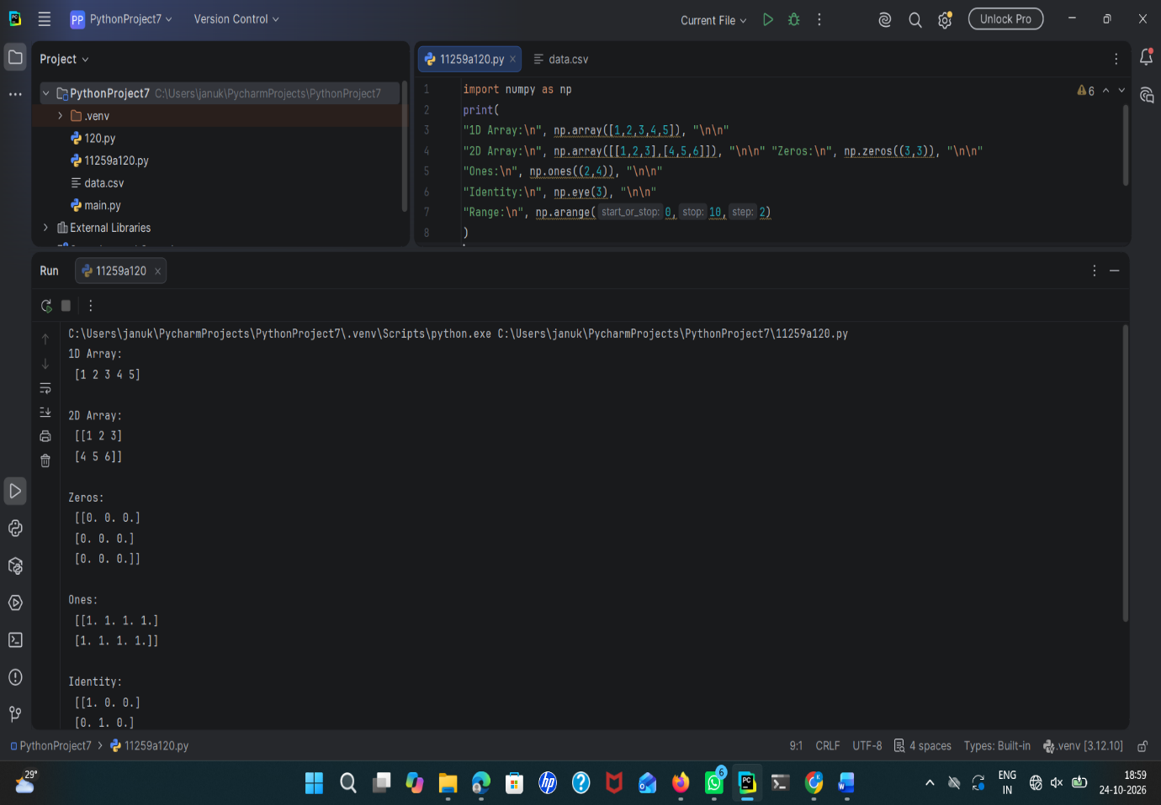
Result
Thus, the Python program to create different types of NumPy arrays was executed successfully, and the corresponding outputs were displayed.

Aim
To perform basic mathematical operations on NumPy arrays, including addition, multiplication, scalar multiplication, square root, mean, and dot product.
Algorithm
- Start the program.
- Import the NumPy library as np.
- Create two NumPy arrays, a = [1, 2, 3] and b = [4, 5, 6].
- Display both arrays.
- Perform addition of arrays a and b.
- Perform element-wise multiplication of arrays a and b.
- Perform scalar multiplication of array a by 10.
- Calculate the square root of each element in array a.
- Calculate the mean of array a.
- Calculate the dot product of arrays a and b.
- Display all the results.
- Stop the program.
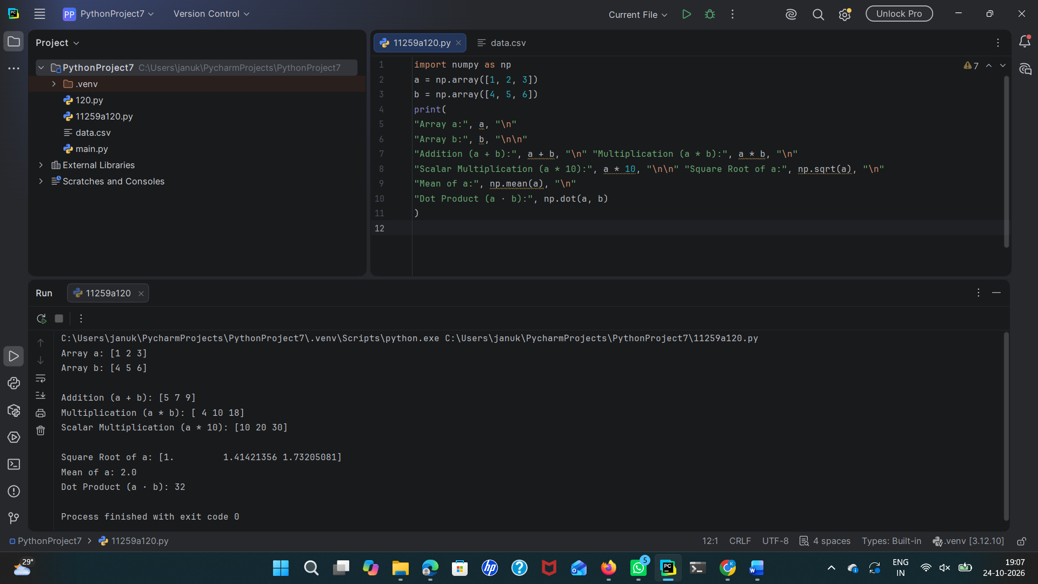
Result
Thus, the basic mathematical operations on NumPy arrays were performed successfully, and the results were displayed.

Aim
To identify and handle missing values in a Pandas DataFrame using isnull(), dropna(), and fillna() methods, including replacing missing Age values with the mean of the column.
Algorithm
- Import the Pandas and NumPy libraries.
- Create a sample DataFrame containing missing values (NaN) in the Age and City columns.
- Display the original DataFrame.
- Identify and count missing values in each column using isnull().sum().
- Remove rows containing missing values using the dropna() method.
- Replace all missing values with 0 using the fillna(0) method.
- Calculate the mean of the Age column and replace missing Age values with the mean.
- Replace missing City values with "Unknown".
- Display the resulting DataFrames.
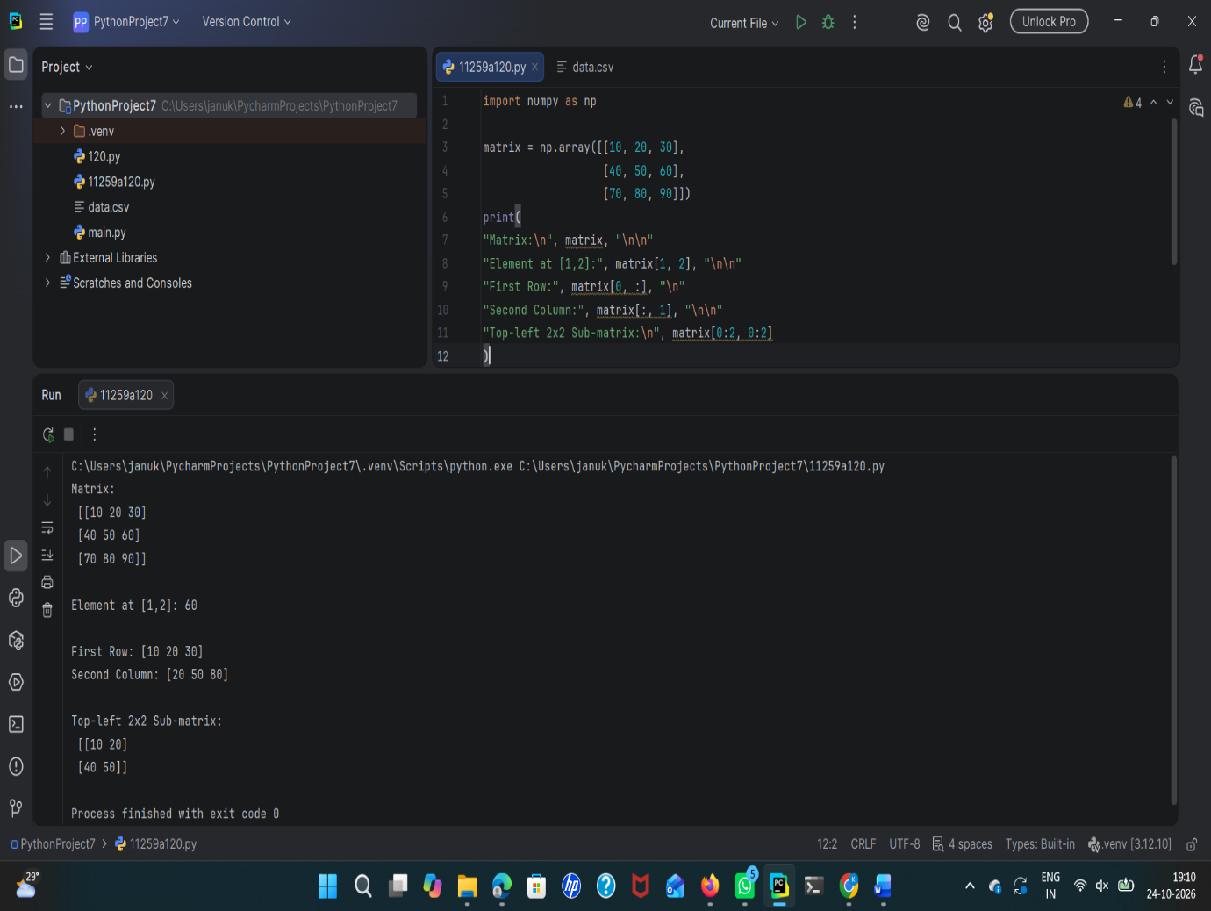

Result
Thus, missing values in the Pandas DataFrame were identified and handled successfully using isnull(), dropna(), and fillna() methods. Missing Age values were replaced with the column mean, and missing City values were replaced with "Unknown".

